**IBM-EPBL/IBM-Project-20074-1659711991**

Natural Disasters Intensity Analysis and Classification using Artificial Intelligence

**TEAM MEMBERS:**

412419104051-KAVANA RAO Y

412419104012-ARCHANA K

412419104128-SUDHARSHINY T A

412419104045-JOE MARIAM.J

412419104107-SAUJANYA K

**Data Flow Diagram:**

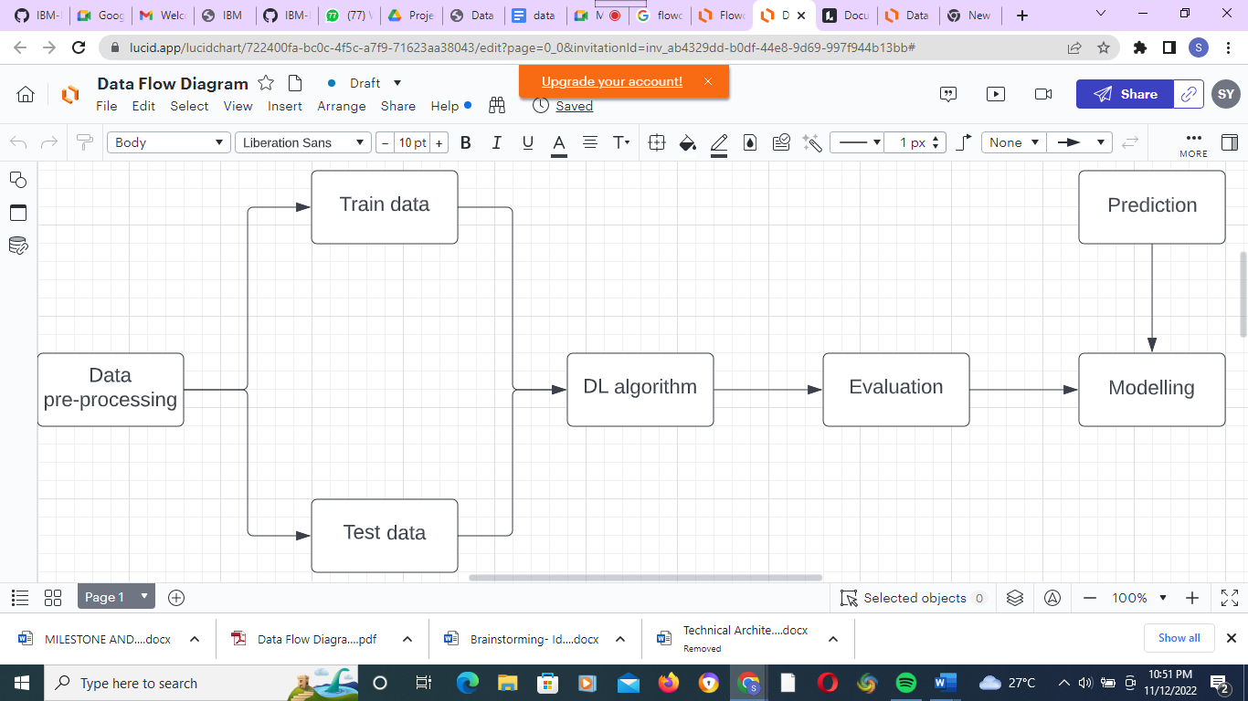

# **User Stories:**

# 

| **User Type** | **Functional Requirement (Epic)** | **User Story Number** | **User Story / Task** | **Acceptance criteria** | **Priority** | **Release** |
| --- | --- | --- | --- | --- | --- | --- |
| **Customer (Mobile user)** | **Upload Data** | **USN-1** | **As a user, I can upload either a live stream, video or photo of the disaster** | **I can upload the data.** | **High** | **Sprint-1** |
| **Functional Requirement (Epic)** | **Obtain Output** | **USN-2** | **As a user, I can receive the classification and the intensity of the disaster** | **I can receive the information about the disaster** | **High** | **Sprint-1** |
| **Customer (Mobile user)** | **Upload Data** | **USN-1** | **As a user, I can upload either a live stream, video or photo of the disaster** | **I can upload the data.** | **High** | **Sprint-1** |
| **Customer (Mobile user)** | **Obtain Output** | **USN-1** | **As a user, I can receive the classification and the intensity of the disaster.** | **I can receive the information about the disaster** | **High** | **Sprint-1** |

# 

# 